ST JOHN’S COLLEGE
CAMBRIDGE

Hand Washing & Hand Sanitiser Protocol
for Students, Staff, Fellows and visitors of St John’s College

St John’s College is committed to the health and safety of its Students, Staff and Fellows therefore in line with the Government health advice regarding reducing exposure risk from Covid-19 please follow the below steps regarding hand washing or the use of hand sanitizing gel, when hand washing cannot be performed.

Handwashing
Hand washing is the single most important measure in reducing the spread of disease and infections. Hands are a repository for micro-organisms and the risk of exposure to diseases and infections are greatly reduced by appropriately and timely washing and/or decontaminating your hands.

Hand washing -how often to wash hands
There is no set frequency for washing hands, it is determined by the procedures and actions; those about to be performed and those completed.
https://www.nhs.uk/live-well/healthy-body/best-way-to-wash-your-hands/

When to wash hands:
- Before and after physical contact, bathing, toileting
- Whenever hands become visibly soiled or after microbial contamination
- Before and after removing any protective clothing (this includes face coverings or masks)
- Before putting on sterile gloves
- After handling contaminated items such as, dressings
- Before and after handling wounds or items contaminated with body fluids
- After handling potentially contaminated laundry and waste
- Before preparing, eating, drinking or handling food
- After visiting the toilet
- After blowing your nose and/or covering a sneeze
- After touching animals, including pets and their food and waste items
- After handling refuse
*not an exhaustive list

How to wash hands, step by step
- Wet hands with water (preferably running).
- Dispense a portion of liquid soap onto wet hands.
- Rub and lather solution.
- Undertake the systematic hand wash technique (see images)
- Rinse hand thoroughly under running water / fresh water.
- Dry hands thoroughly with disposable paper towels (or alternative)
- Discard paper towels in general domestic waste stream.

Washing your hands properly takes about two minutes or as long as singing "Happy Birthday" twice (https://www.who.int/gpsc/clean_hands_protection/en/)
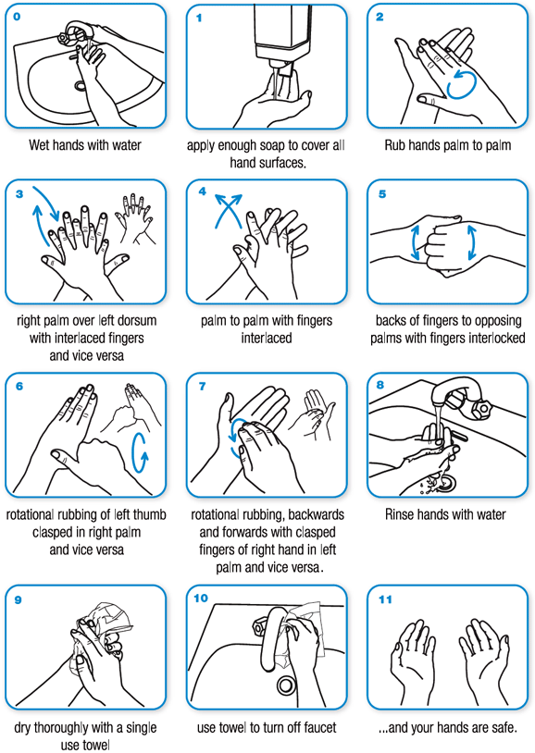

Hand sanitizers
Hand sanitizers (gel or liquid, 60% alcohol or above) are solutions to be placed onto dry hands, where hands are not visibly contaminated and provides an additional method for ensuring hands are clean. They are useful where additional rapid hand cleansing is required. In order for effective hand decontamination to take place the arms should be bare from the elbows down and jewellery removed when possible.
- Ensure there is no obvious contamination of the hands.
- Dispense the required amount of solution onto the dry palms, and then cover all areas of the hands.
- Rub the solution into the hands using the systematic hand rubbing technique.
- Continue rubbing until the solution has dried from the hands.
Do not use:
On hands that are visibly dirty or contaminated with blood / bodily fluids or immediately after washing your hands with soap and water.

Storage of hand sanitizers

Reserve stocks of hand sanitizer (and other flammable liquids) in the workplace should be kept in a lockable metal cupboard. Hand rub/gel must be kept away from naked flames and ignition sources. Dispensers should not be sited directly above or adjacent to electrical sockets or switches.

Sign posting effective hand washing or the use of hand sanitizer/gel to all, will significantly reduce the risk for the members of St John’s to Covid-19 and many other diseases and infections.

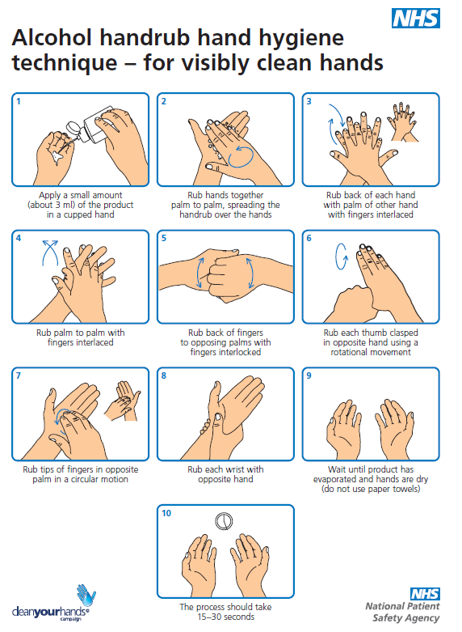

https://www.hey.nhs.uk/patient-leaflet/hand-hygiene-information/

